Ice Breaker – Participant Worksheet
Brands: Look at the following 10 logos. Identify the company using each of the 10 logos.

Logo | Company Name | Logo | Company Name
 |  | 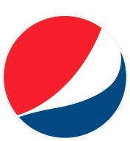
 |  | 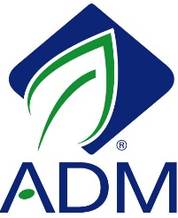
 |  | 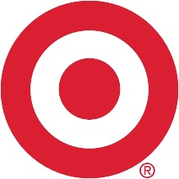

Exercise A – Participant Worksheet
Brands: What do they mean to you?
Look at the following 10 logos. List the first words or phrases you think of that describe the company using each logo.

Logo | Company name | Word(s) or Phrase Description
 | NBC
 | Maserati
 | Time Warner Cable
 | Pepsi
 | Buick
 | Shell
 | Amazon
 | Archer Daniels Midland
 | Applebee’s
 | Target

Exercise B – Participant Worksheet

Words convey various messages. Please review the list below. In the blank beside each word, record whether your impression of this term is generally positive or negative.

Farmer _______________________________ | Locally grown _________________________
Family-owned _________________________ | Agriculture ___________________________
Green industry _________________________ | Animal welfare ________________________
Agribusiness __________________________ | Organic ______________________________
Food safety ____________________________ | Farm worker __________________________

Evaluation for Module 3

For the following statements, please answer by circling a number where 1=strongly disagree, 2=disagree, 3=neither agree nor disagree, 4= agree, and 5=strongly agree.
 |  | Before Workshop |  | After Workshop
a. I understand the concept of branding. |  | 1 2 3 4 5 N/A |  | 1 2 3 4 5 N/A
b. I understand the concept of framing. |  | 1 2 3 4 5 N/A |  | 1 2 3 4 5 N/A
c. I can identify images consumers might view positively. |  | 1 2 3 4 5 N/A |  | 1 2 3 4 5 N/A
d. I can identify words consumers might view positively. |  | 1 2 3 4 5 N/A |  | 1 2 3 4 5 N/A
e. I know the steps to developing effective messages. |  | 1 2 3 4 5 N/A |  | 1 2 3 4 5 N/A
f. I can use messages to promote my products. |  | 1 2 3 4 5 N/A |  | 1 2 3 4 5 N/A
What are the three most important things you feel you have learned in this module?

What have you learned from this module that you plan to implement in the next year?

The amount of time spent on this module was: (Please circle one) | Too Short |  | Just Right | Too Long
The amount of material covered in this module was: (Please circle one) | Too Little |  | Just Right | Too Much

