Week 1: What is aquaculture?
Calendar | Text | Graphic
Week 1  Day 1 (Mon.) | Aquaculture involves breeding, raising, and harvesting aquatic organisms in water. These aquatic organisms–including finfish, bivalve shellfish, shrimp, and other invertebrates, aquatic reptiles, and aquatic plants–are farmed for the ornamental aquarium trade, food, conservation, and other uses.  For more information, visit NOAA Fisheries’ website on aquaculture: https://www.fisheries.noaa.gov/topic/aquaculture | 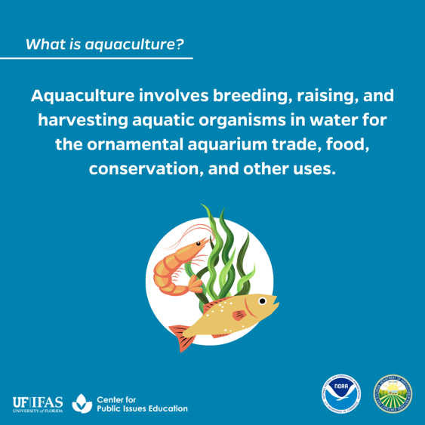
Week 1  Day 2 (Tues.) | Aquaculture simply means farming in water. Aquaculture can take place in either freshwater or saltwater and can occur in tanks or ponds. | 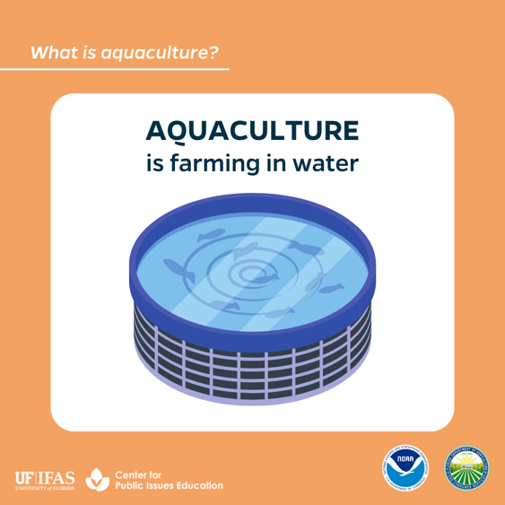
Week 1  Day 3 (Wed.) | Aquaculture can be onshore, offshore, or nearshore. Onshore operations are land-based systems and can include docks. Offshore operations occur in open waters away from land. Nearshore operations are a type of offshore aquaculture that occurs directly on the coast in state waters. | 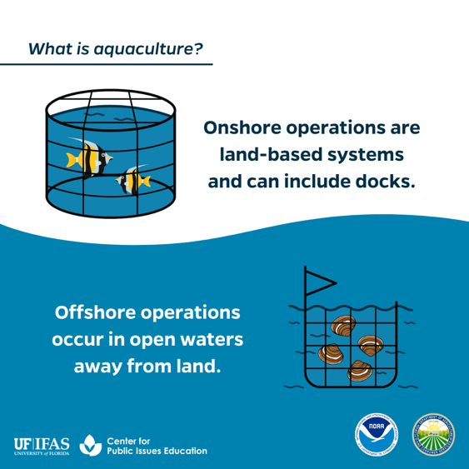

Week 2: Offshore aquaculture in Florida.
Calendar | Text | Graphic
Week 2  Day 1 (Mon.) | Florida’s vast coastal region, climate, and shipping opportunities make it ideal for offshore aquaculture and the production of unique, valuable seafood products. Additionally, the Florida Department of Agriculture and Consumer Services (FDACS), Division of Aquaculture is a “one-stop shop” for Florida’s aquaculture regulations and is recognized as a national leader in aquaculture regulation and development. | 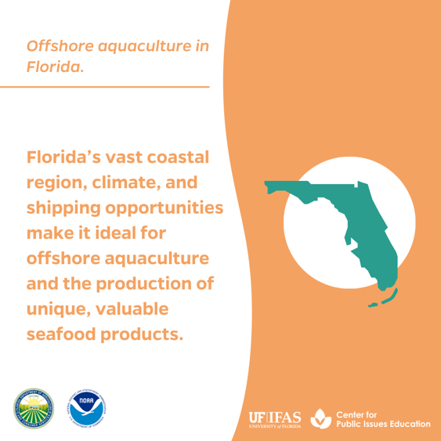
Week 2  Day 2 (Tues.) | Offshore aquaculture involves farming native marine organisms using marine systems that are submerged underwater and suspended off the seafloor. Native marine organisms are raised in and harvested from these underwater systems. | 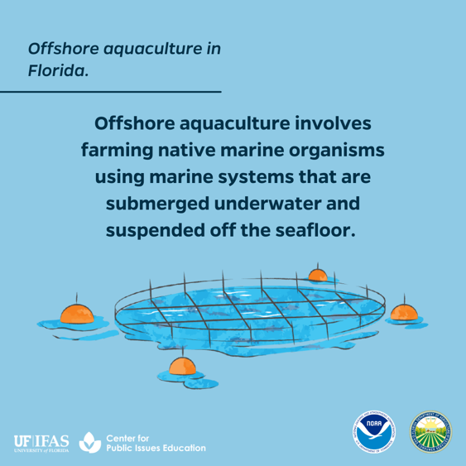
Week 2  Day 3 (Wed.) | Ongoing research projects with state, federal, and academic partners will help determine possible areas in Florida state waters of the Gulf of Mexico for offshore aquaculture operations. | 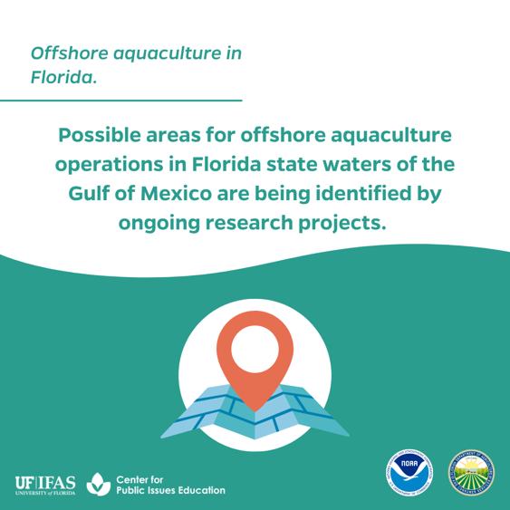

Week 3: Why is offshore aquaculture beneficial?
Calendar | Text | Graphic
Week 3  Day 1 (Mon.) | Offshore aquaculture operations in the U.S. can expand our domestic seafood production and increase food security. According to the Food and Agriculture Organization of the United Nations (FAO), 52% of the seafood consumed globally is farmed.  Visit this interactive story by FAO to learn more: https://www.fao.org/state-of-fisheries-aquaculture/2020/en | 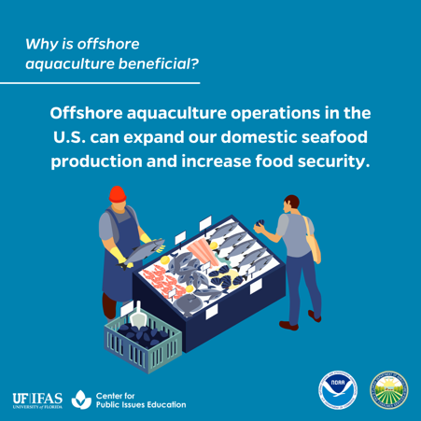
Week 3  Day 2 (Tues.) | According to NOAA Fisheries, responsible offshore aquaculture practices can prepare us to meet future protein demands and work towards achieving several United Nations’ Sustainable Development Goals by 2030.  Check out this article by NOAA Fisheries to learn more: https://www.fisheries.noaa.gov/feature-story/aquaculture-supports-sustainable-earth | 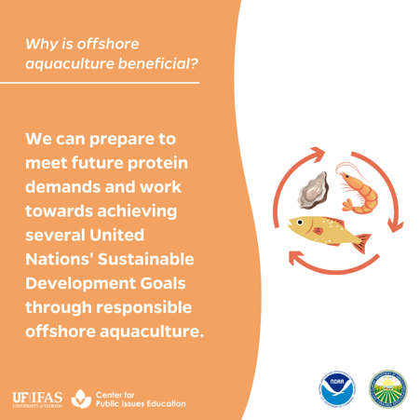
Week 3  Day 3 (Wed.) | Offshore aquaculture can help take the pressure off wild-capture fishery resources and supplement sustainable wild-capture fisheries. | 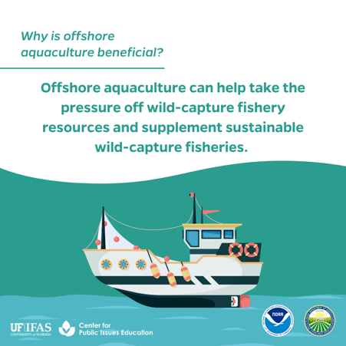
Week 3  Day 4 (Thurs.) | Offshore aquaculture operations can enhance employment and economic opportunities in coastal communities. This supports the Blue Economy, which are jobs and industries that rely on ocean resources.  For more information about the Blue Economy, visit NOAA’s page on Our Coastal and Ocean Economy: https://oceanservice.noaa.gov/economy/ | 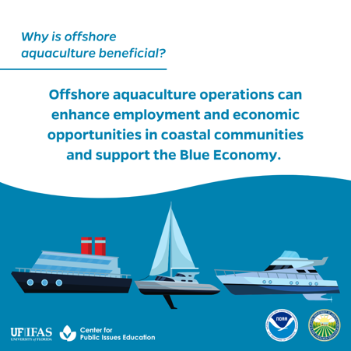

Week 4: How are concerns being addressed?
Calendar | Text | Graphic
Week 4  Day 1 (Mon.) | Water quality is an important environmental concern related to aquaculture. As a best practice, marine systems are placed in deep waters with currents that allow for flushing to reduce the buildup of nutrients. Florida also requires rigorous environmental assessments and compliance with water quality regulations such as the Clean Water Act. When offshore operations are properly sited and managed, nutrients are nearly undetectable immediately outside of the system. | 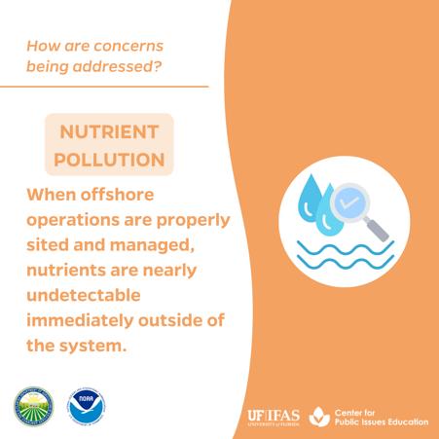
Week 4  Day 2 (Tues.) | Fish escapes present a potential risk to the natural environment and wild fish populations via competition and spread of disease. Proper animal husbandry, routine system maintenance, and escape recovery plans will prevent and manage fish escapes to protect natural resources. Escaped farmed fish will also likely die, quickly become prey, or fail to reproduce due to their decreased fitness in the wild.  For more information on this topic, visit: https://media.fisheries.noaa.gov/2022-03/Fact-Sheet-Potential-Risks-of-Aquaculture-Escapes.pdf | 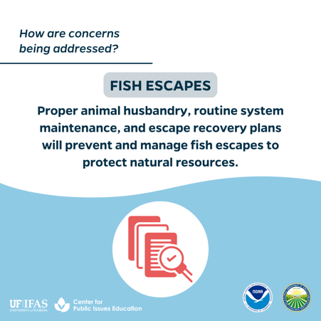
Week 4  Day 3 (Wed.) | Concern exists that farmed fish could mix with wild fish populations and produce negative genetic consequences. Farmed species in Florida MUST be native and originate from local genetics of the wild population. Non-native and transgenic, or genetically altered, organisms are strictly prohibited for farming in Florida state waters.  For more information on this topic, visit: https://media.fisheries.noaa.gov/2022-03/Fact-Sheet-Potential-Risks-of-Aquaculture-Escapes.pdf | 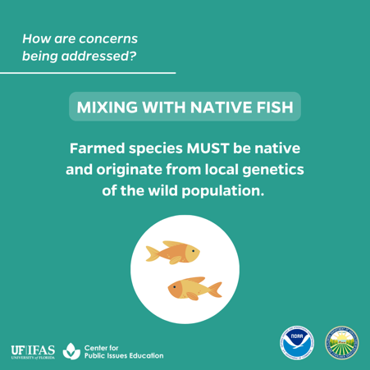
Week 5  Day 1 (Mon.) | Public concern exists related to the use of preventative treatments in offshore aquaculture operations potentially causing human health risks or antibiotic resistance. Proper animal husbandry and care to prevent disease is an industry-standard best practice to avoid the use of expensive treatments. The high cost, intensive labor required, and strict regulations involved to use preventative treatments restricts their use in all but the most severe cases. | 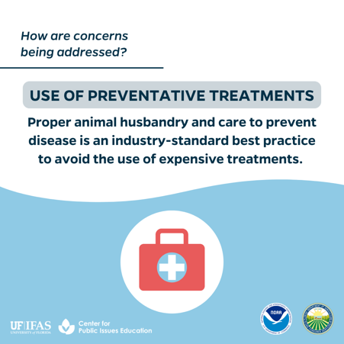
Week 5  Day 2 (Tues.) | To avoid disrupting maritime navigation and impacting access to fishers, a sufficient distance must exist between offshore aquaculture operations and marine traffic routes. | 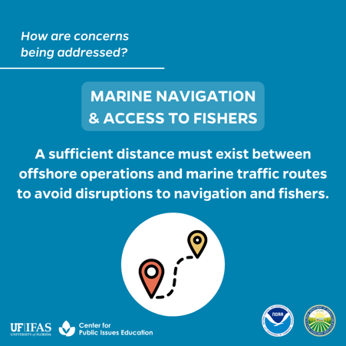
Week 5  Day 3 (Wed.) | There is concern that this growing industry may compete with or displace existing fishers and other ocean users. However, offshore aquaculture can present numerous opportunities for economic growth, jobs in rural and working waterfront communities, enhanced domestic food security, and preservation of coastal heritage and traditions. | 